Name and Function | Picture
The Pituitary Gland is often called the master gland, although it is no bigger than a pea. It secretes hormones based on emotions and changing seasons. The pituitary gland produces growth hormone, which stimulates growth, prolactin, which stimulates milk production in females, thyrotropin, which stimulates the thyroid gland, and corticotropin, which stimulates the adrenal gland. The pituitary gland also produces endorphins, which reduce feelings of pain, and oxytocin, which triggers contractions in a woman giving birth. | 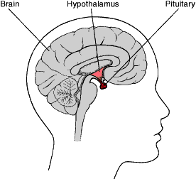
The Pancreas is located in the abdomen, and secretes insulin and glucagon into the bloodstream to help regulate blood sugar levels. | 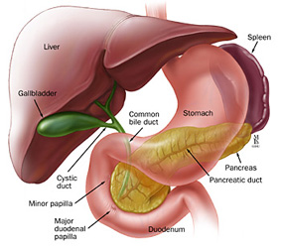
A female’s Ovaries are located in her abdomen, in the pelvic region. They secrete hormones such as estrogen and progesterone. Estrogen is key in puberty in females, and both estrogen and progesterone are essential parts of regulating a woman’s menstrual cycle. | 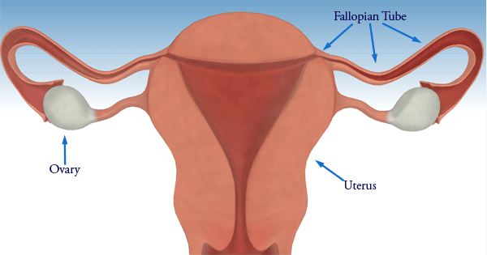
A male’s Testes are located in the scrotum, and they secrete hormones called androgens. The most common androgen is called testosterone, which is also known as the male sex hormone. Testosterone helps the body know when to start puberty. | 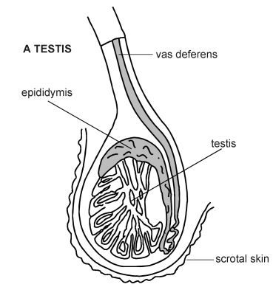
The Thyriod Gland is located in the neck, and is shaped similar to a butterfly. It produces thyroxine and triiodothyronine, which control the metabolism. Thyroid hormones help kids to develop and grow, and are very crucial to life. | 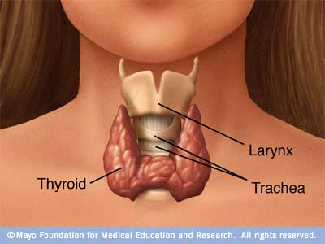
In our bodies, we have two Adrenal Glands, one on top of each kidney. They are divided into two parts, which each perform different tasks. The outer part is called the adrenal cortex, and produces corticosteroids, which regulate the body’s metabolism, stress, salt and water retention, and sexual development and function. The inner part is called the adrenal medulla, which produces catecholamines such as epinephrine, which is also known as adrenaline. | 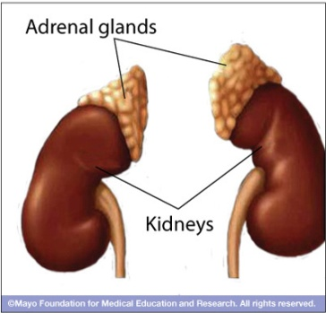

Photo Sources:
Pituitary Gland: http://www.cushings-help.com/images/pituitary.gif
Pancreas: http://lizst.onc.jhmi.edu/CAPS3/images/abdomen_pancreas.jpg
Ovaries: http://www.dimensionsinfo.com/wp-content/uploads/2009/11/Ovaries.gif
Testes: http://medical.cdn.patient.co.uk/images/i33_l.jpg
Thyriod: http://www.mayoclinic.com/images/image_popup/thyroid.jpg
Adrenal: http://www.mayoclinic.com/images/image_popup/mcdc7_adrenal_glands.jpg

